**Dear Respected Dean**

## In accordance with the vision and mission of the College and its role in the preparation of a highly efficient clinical pharmacist and the College's interest in integration of the students personality aspects as well as their academic achievement. The committee of student activity has the honor to submit the report of the activity that held inside and outside the college during the academic year 2015-2016.

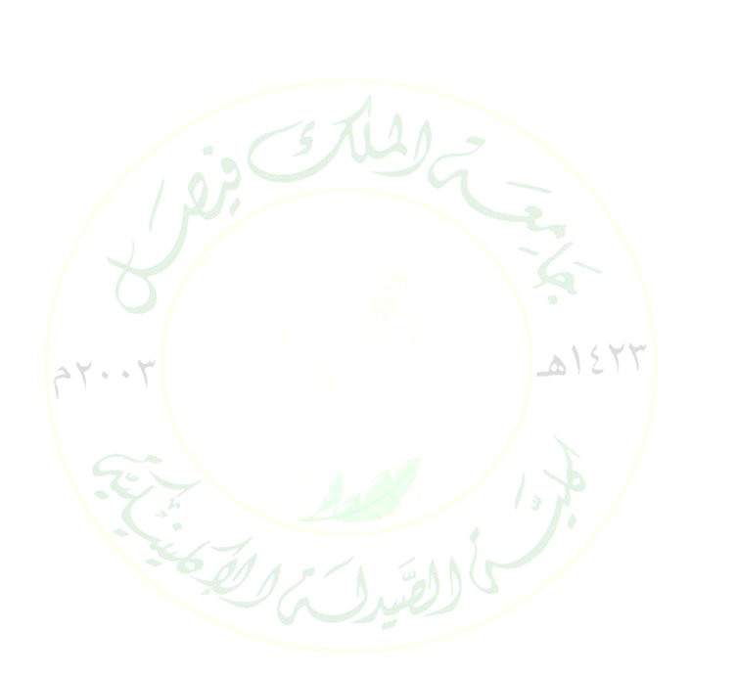

1. **Male student’s activates**
   1. **White Coat Ceremony 12th**

In accordance with the vision and mission of the College and its role in the preparation of a highly efficient clinical pharmacist and the College's interest in integration of the students personality aspects as well as their academic achievement, the collage has prepared a welcoming and guidance day for the first year students. Date: Sunday 23-8-2015

Time 9.00- 11.30.Venue: Auditorium GB-39, college of clinical pharmacy

## Pharmacist Day Celebration on 17/9/2015

Student services committee has celebrated the pharmacist day in the college. Students presented their activities in different recreational corners and dressed the Saudi pharmacist logos on their chests. A lot of information has been delivered to the students about the history of pharmacy colleges in addition to the workplaces after graduation.

## GCC Pharmaceutical Congress 5-8 October 2015 Dubai, UAE

An elite group of students (7 males) and (4 females) under the supervision of Dr. Bandar bin Isa Al Dhubaib and Dr. Omar Mohafez and Thamer bin Hamad have participated in a scientific conference of colleges of pharmacy in the Gulf Cooperation Council, which was held in the states UAE in the period of 5-8 / 10/2015. Our college won the award for best poster and the third place in best student research.

## Participation in King Faisal Hospital opening ceremony in Al-Hasa on 8.10.2015

To activate the role of community participation, College of clinical pharmacy has send team of students to attend the opening ceremony of King Faisal Hospital.

## Ajnadayn high school visit on 28-11-2015

One of the pillars of the vision and message of the College of Clinical Pharmacy is the community engagement. To activate the role of community participation and to provide the high school students with all the information on the study in the college and informed them about the requirements for enrolling in the college in addition to the career chances for Pharm. D.



## COCP participated in exhibition "Your Health Concern us 2" on 7/1/2016

College of Clinical Pharmacy participated in the awareness exhibition organized by Directorate of Health Affairs in Al-Hasa at Ibrahim Palace, to raise health awareness. That was over five days starting on Thursday 7/1/2016. Where students educate visitors about the contents of home pharmacy and how, when to use these drugs, store and get rid of them. Also the importance of counselling a pharmacist upon taking OTC medicines.

## Awareness campaign of obesity and related diseases in college of sciences on 10.2.2016.

As a part of the vision and message of the College of Clinical Pharmacy, thirteen students under supervision of Dr. Omar Mohafez visited college of computer sciences to for awareness of obesity and its related diseases

## 8- University and community together build up future of our generation

The college has participated in the exhibition with thirty-six students (males and females) and three faculty members of student services committee. Our students provided the high school students with all the information on the study in the college and informed them about the requirements for enrolling in the college in addition to the career chances for Pharm. D.

## Female students activates

1. **COCP (female) organized workshop on "CPR" (Be a lifesaver) on** 11/11/2015 & 9/12/2015

Student guidance and counselling committee of COCP (female section) organized a demonstrative workshop on cardio-pulmonary rescue (CPR). The workshop was delivered by student Fatimah Hejji Al-Turaifi with assistance of some of her colleagues. Miss Fatima is registered as BLS provider from Saudi Heart Association. This was carried three repeated times

on Wednesdays 11/11/2015 & 9/12/2015 at college auditorium. And at deanship of female students affairs on Wednesday 18/11/2015.

## DUPHAT Conference 2016

COCP pharm D students participated and presented their research work at Dubai International Pharmaceuticals and Technologies Conference and Exhibition (DUPHAT), Dubai, UAE held from 15th – 17th March 2016. Student Maryam Almulhim won 1st Best pharmacy student oral presentation award for her research work entitled "Design & synthesis of new diclofenac derivative as anti-inflammatory agent" in collaboration with her colleagues, Sara Alsubaie & Hala Aljeneede.



## COCP participated in exhibition "Your Health Concern us 2" on 7/1/2016

COCP established a corner under the slogan "From my pharmacy start my safety," where students educate visitors about the contents of home pharmacy and how, when to use these drugs, store and get rid of them. Also the importance of councelling a pharmacist upon taking OTC medicines and reading the label of medication.

## 8th White Coat Ceremony on Sunday 8-11-1436

In accordance with the vision and mission of the College and its role in the preparation of a highly efficient clinical pharmacist and the College's interest in integration of the students personality aspects as well as their academic achievement, the collage has prepared a welcoming and guidance day for the first year students

## College of Clinical Pharmacy celebrated first Saudi pharmacist Day "1 minute to explain"

Student service committee organized celebration of Saudi pharmacist Day on 16-17 September 2015. Where students introduced the college, its history, who is a clinical pharmacist, accreditation and certification obtained by the college and the reasons for obtaining such international recognition. They highlighted clinical pharmacy profession and its importance to society. This event contributes to the Saudi pharmacist on his day, in defining pharmaceutical health services, and serving the community regarding health care, pharmaceutical counseling, pharmaceutical specialist, in addition to contributing to the development of pharmacy students' capacities in Saudi Arabia along all universities, and urged them to volunteer work and serve community. That event was at the initiative, with

the support of the organizing group (Pharmacist with Impact) under the slogan "one minute to explain". COCP awareness corner impressed everyone, who praise the effort expended, and take advantage of the distinct information offered and health awareness.

## COCP organized workshop entitled "It's time to make a change"

COCP organized workshop entitled "It's time to make a change" on Wednesday 18/11/2015 during activity time 11-12 at auditorium 2052. Where student Fatimah Alshiekh Mubarak delivered the lecture for her colleagues from different colleges. She started from how to put an idea into steps for scientific research until publication. She also discussed her experience during her own research. All attendees were motivated and involved in interactive discussion and inquires. The activity was organized and supervised by Dr. Nashwa Zaher, coordinator of student Guidance and Counselling committee at COCP.



## COCP celebrated event of "Family Safeness" under the slogan (Love and tenderness breeds Safeness)

College of Clinical Pharmacy (female section) organized Family Safeness event under the slogan of the (Love and Tenderness Breeds Safeness) It was held on Tuesday, 24/11/2015 from 10:00 am-12 at the main auditorium COCP (female section). Where student Sarah Mahmoud Alsafar in cooperation with her colleague Hajar Almaziel presented lecture entitled "My serenity house". They discussed safe environment for a child practically and psychologically at home, the child's relationship with family members, providing emotional care for child at all levels and the appropriate and inappropriate methods of punishment and their effect on the child.

# Student services committee

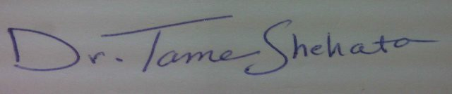

**Dr. Tamer Shehata**